AJ Young

January 5, 2021

Big Mountain Project Report

Based on our parameter prediction model, it is recommended that Big Mountain invest in building an additional ski run in order to support a $2 price increase that translates to approximately $3.4 million in revenue this upcoming season.

As it currently stands, Big Mountain currently charges $81 for tickets during their ski season. However, our pricing model, which incorporates ski resort pricing data on a national level, supports a price increase to $96, with $10 error. As demonstrated in the chart below, Big Mountain’s ticket prices are already significantly higher than those of other Montana ski resorts, and such a steep and immediate price increase is a potential challenge.

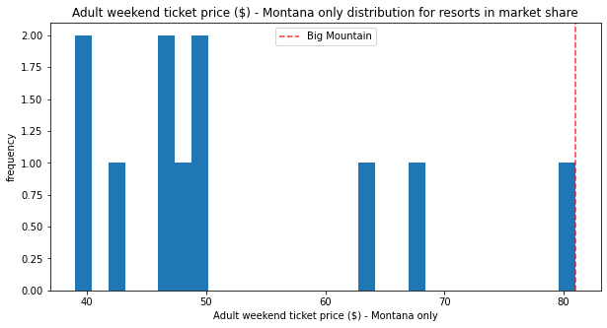

Our model demonstrates that ski patrons will pay more for more ski runs, and additionally, a $2 increase is less significant than an immediate $15 increase in ticket price. Next steps are investigating the upfront and ongoing costs of investing in an additional ski run in order to verify that Big Mountain continues to remain profitable after ski run completion.